**Configure Multi-Area OPSF**

Jeffrey Xu

ccnp (cisco certified network professional)

Sept. 2018

NEWPORT HIGH SCHOOL, WA

## purpose:

The purpose of this lab is to review both IPv4 and IPv6 OSPF (Open Shortest Path First), a convenient and scalable routing protocol that is widely used in enterprise network. In addition to refreshing the memory, this lab also helps us to learn Multi-Area OSPF, a protocol that optimizes routing in an even larger scale network.

## background

OSPF is an Internal Gateway Protocol (IGP) that routes based on link-state information. Each router knows the route to every neighbor in its area. Take an analogy: there are eight rooms in a building and each room has a resident. In OSPF, each resident knows all eight routes to those eight rooms. When a new neighbor is added, all residents must communicate and re-learn their routes.

Single Area OSPF works fine in a small scale: a person can deal with 8 routes. However, if there are 100 rooms in a building, each resident must remember 100 routes. In this way, routers will severely slow down because their resource is devoted to maintaining that giant routing table. What’s more, much calculation will be needed as a new router is introduced.

Multi-Area OSPF mediates a giant routing table. Instead of putting all rooms in a building (one area), Multi-Area OSPF groups rooms (routers) into different buildings (areas). In this way, 100 routers are grouped into, for example, 10 areas. If resident 1 want to communicate with 12, he only needs the route building 2. In this way, resident 1 only need 9 routes to 9 other buildings (area) instead of 90 routes to 90 other residents.

## summary

First, we made a topology graphic using Packet Tracer, label IP addresses with Power Point. Then, we implemented the topology into physical routers. Because we did not have enough routers, a Catalyst 3750 Metro (layer 3 switch) assumes the role of Main Router. R1-R5 were 5 Cisco 2950 routers.

After assigning IPv4 addresses to each port on routers, we set up Multi-Area OSPFv2 connection between these routers. Next, we assigned IPv6 addresses and configured Multi-Area OSPFv3 and established the connection.

## Topology

## 

## Lab commands

| Commands (not case sensitive) | Purpose | Configuration Mode |
| --- | --- | --- |
| show ip protocols | To verify Multi-Area OSPF | Privileged Exec |
| router ospf 1 | Create IPv4 OSPF process on a router | Global Config |
| network 10.10.10.0 0.0.0.255 area 3 | Assign IPv4 network 10.10.10.0/24 (Class C—a network of 255 addresses) to area 3 | Global Config |
| ipv6 ospf 1 area 3 | Assign IPv6 network on THAT interface to area 3 | Config-int |
| ipv6 unicast routing | Enable IPv6 routing on routers/layer 3 switches | Global Config |
| sdm prefer dual-ipv4-and-ipv6 default | Addition step required to enable Ipv6 routing on a layer 3 switches | Global Config |
| no switchport | Enable THAT switchport to act as a router port | Config-int |

## Configurations :

### Main router (catalyst 3750) config:

hostname MainRouter

ipv6 unicast-routing

interface FastEthernet1/0/1

no switchport

ip address 10.10.1.2 255.255.255.0

ipv6 address 2001::1/64

ipv6 ospf 1 area 0

interface FastEthernet1/0/2

no switchport

ip address 10.10.2.2 255.255.255.0

ipv6 address 2007::2/64

ipv6 ospf 1 area 0

interface FastEthernet1/0/3

no switchport

ip address 10.10.3.2 255.255.255.0

ipv6 address 2008::3/64

ipv6 ospf 1 area 0

router ospf 1

network 10.10.1.0 0.0.0.255 area 0

network 10.10.2.0 0.0.0.255 area 0

network 10.10.3.0 0.0.0.255 area 0

ipv6 router ospf 1

### R1 (Cisco 2950 router) config

hostname R1

ipv6 unicast-routing

interface GigabitEthernet0/0

ip address 10.10.1.1 255.255.255.0

ipv6 address 2001::4/64

ipv6 ospf 1 area 0

interface GigabitEthernet0/1

ip address 10.10.4.1 255.255.255.0

ipv6 address 2002::1/64

ipv6 ospf 1 area 1

router ospf 1

network 10.10.1.0 0.0.0.255 area 0

network 10.10.4.0 0.0.0.255 area 1

ipv6 router ospf 1

### R2 (Cisco 2950 router) config

hostname R2

ipv6 unicast-routing

interface GigabitEthernet0/0

ip address 10.10.2.1 255.255.255.0

ipv6 address 2007::5/64

ipv6 ospf 1 area 0

interface GigabitEthernet0/1

ip address 192.168.2.1 255.255.255.0

ipv6 address 2003::1/64

ipv6 ospf 1 area 2

router ospf 1

router-id 2.2.2.2

network 10.10.2.0 0.0.0.255 area 0

network 192.168.2.0 0.0.0.255 area 2

ipv6 router ospf 1

### R3 (CISCO 2950 ROUTER) CONFIG

hostname R3

ipv6 unicast-routing

interface GigabitEthernet0/0

ip address 10.10.3.1 255.255.255.0

ipv6 address 2008::6/64

ipv6 ospf 1 area 0

interface GigabitEthernet0/1

ip address 10.10.5.1 255.255.255.0

ipv6 address 2004::1/64

ipv6 ospf 1 area 3

router ospf 1

router-id 3.3.3.3

network 10.10.3.0 0.0.0.255 area 0

network 10.10.5.0 0.0.0.255 area 3

ipv6 router ospf 1

### R4 (Cisco 2950 router) config

hostname R4

ipv6 unicast-routing

interface GigabitEthernet0/0

ip address 10.10.4.1 255.255.255.0

ipv6 address 2002::2/64

ipv6 ospf 1 area 1

interface GigabitEthernet0/1

ip address 192.168.1.1 255.255.255.0

ipv6 address 2005::1/64

ipv6 ospf 1 area 1

router ospf 1

router-id 4.4.4.4

network 10.10.4.0 0.0.0.255 area 1

network 192.168.1.0 0.0.0.255 area 1

ipv6 router ospf 1

### R5 (Cisco 2950 router) confiG

hostname R5

ipv6 unicast-routing

interface GigabitEthernet0/0

ip address 10.10.5.2 255.255.255.0

ipv6 address 2004::2/64

ipv6 ospf 1 area 0

interface GigabitEthernet0/1

ip address 192.168.3.1 255.255.255.0

ipv6 address 2006::1/64

ipv6 ospf 1 area 3

router ospf 1

router-id 5.5.5.5

network 10.10.5.0 0.0.0.255 area 3

network 192.168.3.0 0.0.0.255 area 3

ipv6 router ospf 1

## Problems

We had trouble turning a layer 3 switch into a router. To solve this, we first typed “sdm prefer dual-ipv4-and-ipv6 default” command into Global Configuration of the switch. We then saved the config and reload the switch. After doing that, we still couldn’t assign ip address to the ports. So, we did “no switchport” command in that port. Finished with all those steps, a layer 3 switch works the same as a router.

In addition, the routers and switches that we worked with had configurations saved on them. And the previous configurations administratively shutdown some ports, which confused us for a long time (we thought it was a layer one problem). To solve this, we did “erase running-config startup-config” and then reload.

IPv6 Multi-Area OSPF didn’t work properly when we first assigned it. Then, we figured out that we need router-id for each router to make IPv6 OSPF work. After doing that, everything worked fine.

## Conclusion

The purpose of this lab was for us to familiarize with the content we learned last year, with a little advancement of Multi-Area OSPF. Since we didn’t have enough routers, we had to learn how to use a layer 3 switches as routers. After all, it was a good reminder of the things I learnt last year, with a little exploration.

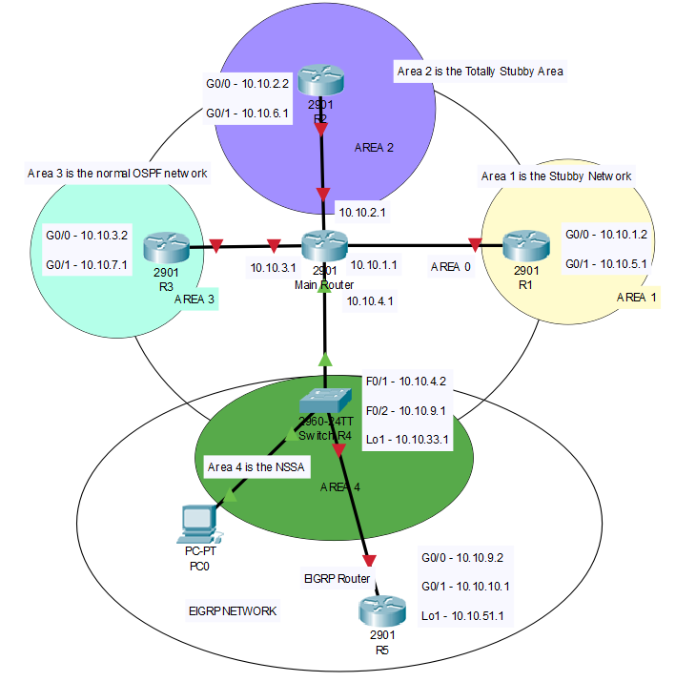

* Main Router is in backbone area 0.
* R1, R2, R3, SwitchR4 are all connected to area 0, but each is also independently in area 1, 2, 3, 4.
* R5 is the EIGRP router that LSAs from provides external network. R5 is not a part of OSPF areas, but it is connected to OSPF network.
* I used SwitchR4 for ASBR instead of an actual router, because I want to capture the nssa LSA type 7 traffic that it sends to area 4. In order to do this, I need three ports, one to Main Router, one to my PC and another one to R5. However, there are only two ports on the routers I have. Thus, I must use a layer 3 switch as a router.

## router IPv4 routes

**MainRouter(config)#**do show ip routes

Codes: L - local, C - connected, S - static, R - RIP, M - mobile, B – BGP, D - EIGRP, EX - EIGRP external, O - OSPF, IA - OSPF inter area, N1 - OSPF NSSA external type 1, N2 - OSPF NSSA external type, E1 - OSPF external type 1, E2 - OSPF external type 2, i - IS-IS, su - IS-IS summary, L1 - IS-IS level-1, L2 - IS-IS level-2, ia - IS-IS inter area, * - candidate default, U - per-user static route, o - ODR, P - periodic downloaded static route, H - NHRP, l – LISP, + - replicated route, % - next hop override

Gateway of last resort is not set

10.0.0.0/8 is variably subnetted, 11 subnets, 2 masks

C 10.10.1.0/24 is directly connected, FastEthernet1/0/1

L 10.10.1.1/32 is directly connected, FastEthernet1/0/1

C 10.10.2.0/24 is directly connected, FastEthernet1/0/2

L 10.10.2.1/32 is directly connected, FastEthernet1/0/2

C 10.10.3.0/24 is directly connected, FastEthernet1/0/3

L 10.10.3.1/32 is directly connected, FastEthernet1/0/3

C 10.10.4.0/24 is directly connected, FastEthernet1/0/4

L 10.10.4.1/32 is directly connected, FastEthernet1/0/4

O IA 10.10.9.0/24 [110/2] via 10.10.4.2, 00:19:13, FastEthernet1/0/4

O IA 10.10.33.1/32 [110/2] via 10.10.4.2, 00:22:40, FastEthernet1/0/4

O E2 10.10.51.0/24 [110/100] via 10.10.4.2, 00:18:27, FastEthernet1/0/4

**R1(config)#**do show ip routes

10.0.0.0/8 is variably subnetted, 8 subnets, 2 masks

C 10.10.1.0/24 is directly connected, GigabitEthernet0/0

L 10.10.1.2/32 is directly connected, GigabitEthernet0/0

O 10.10.2.0/24 [110/2] via 10.10.1.1, 00:08:20, GigabitEthernet0/0

O 10.10.3.0/24 [110/2] via 10.10.1.1, 00:08:20, GigabitEthernet0/0

O 10.10.4.0/24 [110/2] via 10.10.1.1, 00:08:20, GigabitEthernet0/0

O IA 10.10.9.0/24 [110/3] via 10.10.1.1, 00:08:20, GigabitEthernet0/0

O IA 10.10.33.1/32 [110/3] via 10.10.1.1, 00:08:20, GigabitEthernet0/0

O E2 10.10.51.0/24 [110/100] via 10.10.1.1, 00:08:20, GigabitEthernet0/0

**R2(config)#**do show ip routes

10.0.0.0/8 is variably subnetted, 8 subnets, 2 masks

O 10.10.1.0/24 [110/2] via 10.10.2.1, 00:07:53, GigabitEthernet0/0

C 10.10.2.0/24 is directly connected, GigabitEthernet0/0

L 10.10.2.2/32 is directly connected, GigabitEthernet0/0

O 10.10.3.0/24 [110/2] via 10.10.2.1, 00:07:58, GigabitEthernet0/0

O 10.10.4.0/24 [110/2] via 10.10.2.1, 00:07:58, GigabitEthernet0/0

O IA 10.10.9.0/24 [110/3] via 10.10.2.1, 00:07:58, GigabitEthernet0/0

O IA 10.10.33.1/32 [110/3] via 10.10.2.1, 00:07:58, GigabitEthernet0/0

O E2 10.10.51.0/24 [110/100] via 10.10.2.1, 00:07:58, GigabitEthernet0/0

**R3(config)#**do show ip routes

10.0.0.0/8 is variably subnetted, 8 subnets, 2 masks

O 10.10.1.0/24 [110/2] via 10.10.3.1, 00:06:56, GigabitEthernet0/0

O 10.10.2.0/24 [110/2] via 10.10.3.1, 00:07:50, GigabitEthernet0/0

C 10.10.3.0/24 is directly connected, GigabitEthernet0/0

L 10.10.3.2/32 is directly connected, GigabitEthernet0/0

O 10.10.4.0/24 [110/2] via 10.10.3.1, 00:08:47, GigabitEthernet0/0

O IA 10.10.9.0/24 [110/3] via 10.10.3.1, 00:08:47, GigabitEthernet0/0

O IA 10.10.33.1/32 [110/3] via 10.10.3.1, 00:08:47, GigabitEthernet0/0

O E2 10.10.51.0/24 [110/100] via 10.10.3.1, 00:08:47, GigabitEthernet0/0

**SwitchR4(config)#**do show ip routes

10.0.0.0/8 is variably subnetted, 10 subnets, 2 masks

O 10.10.1.0/24 [110/2] via 10.10.4.1, 00:10:01, FastEthernet1/0/1

O 10.10.2.0/24 [110/2] via 10.10.4.1, 00:10:55, FastEthernet1/0/1

O 10.10.3.0/24 [110/2] via 10.10.4.1, 00:12:35, FastEthernet1/0/1

C 10.10.4.0/24 is directly connected, FastEthernet1/0/1

L 10.10.4.2/32 is directly connected, FastEthernet1/0/1

C 10.10.9.0/24 is directly connected, FastEthernet1/0/2

L 10.10.9.1/32 is directly connected, FastEthernet1/0/2

C 10.10.33.0/24 is directly connected, Loopback1

L 10.10.33.1/32 is directly connected, Loopback1

D 10.10.51.0/24 [90/156160] via 10.10.9.2, 00:17:27, FastEthernet1/0/2

**R4(config)#**do show ip routes

10.0.0.0/8 is variably subnetted, 9 subnets, 2 masks

D EX 10.10.1.0/24

[170/1711616] via 10.10.9.1, 00:02:20, GigabitEthernet0/0

D EX 10.10.2.0/24

[170/1711616] via 10.10.9.1, 00:03:15, GigabitEthernet0/0

D EX 10.10.3.0/24

[170/1711616] via 10.10.9.1, 00:04:55, GigabitEthernet0/0

D EX 10.10.4.0/24

[170/1711616] via 10.10.9.1, 00:09:47, GigabitEthernet0/0

C 10.10.9.0/24 is directly connected, GigabitEthernet0/0

L 10.10.9.2/32 is directly connected, GigabitEthernet0/0

D EX 10.10.33.0/24

[170/1711616] via 10.10.9.1, 00:09:47, GigabitEthernet0/0

C 10.10.51.0/24 is directly connected, Loopback1

L 10.10.51.1/32 is directly connected, Loopback1

## Opsf Packet captured with wireshark

### Normal ospf area

### 

Legend: yellows are the hello packets, and blacks are anything other than the hellos packets. Type 1-2 LSA for intra-area, type 3 for inter-OSPF areas, and type 4-5 for external networks (in this case, our EIGRP network).

In a normal OSPF area, I found that LSA-type 1 through 5 packets flow freely in OSPF networks, creating lots of traffic. In this specific diagram, type 1-2 LSA are not showed, but I did capture them in other packets.

### OSPF stubby area Wireshark Capture

### 

As you can see for the OSPF picket type summary, only LSA-type 1, 2 and 3 are circulating in this network. Since LSA-type 4 and 5—which are associated the propagation of external routes—are filtered, only OSPF area packets (including OSPFs in other areas) are presented in a Stubby OSPF area.

### OSPF totally stubby Wireshark Capture

### 

### Like in Stubby area, no type 4 and 5 LSA are allowed. Type 3 LSAs are only allowed if they are default summary routes. In this packet, only one LSA-type 3 is seemed, so it is probably the default summary routes that summarized the OSPF networks other areas. In other packets, we mostly see LSA-type 1 or type 2 alone. Like what’s shown below:

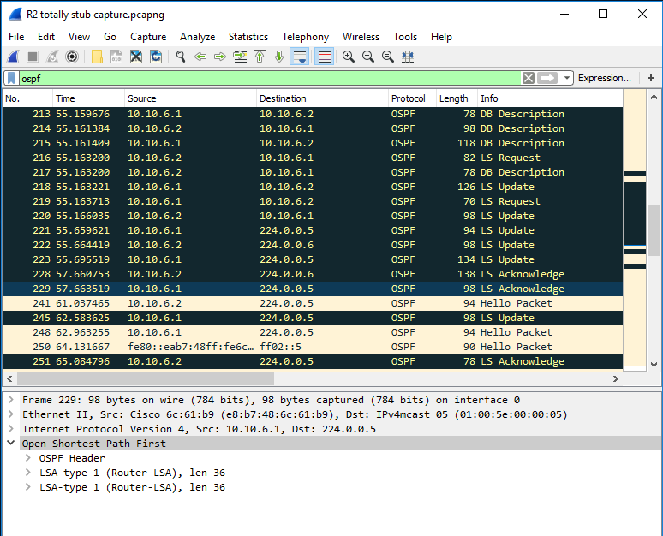

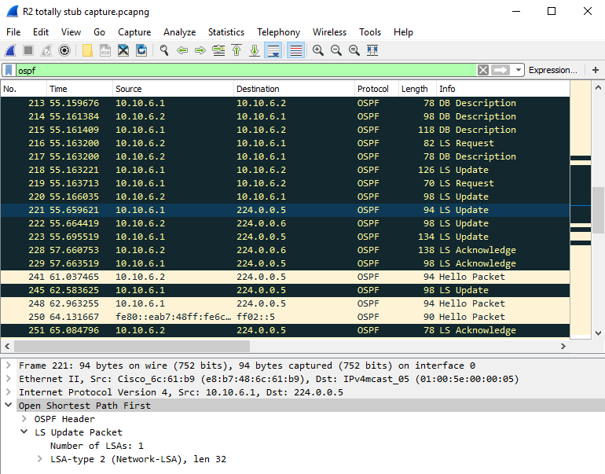

### NSSA (no so stubby area)

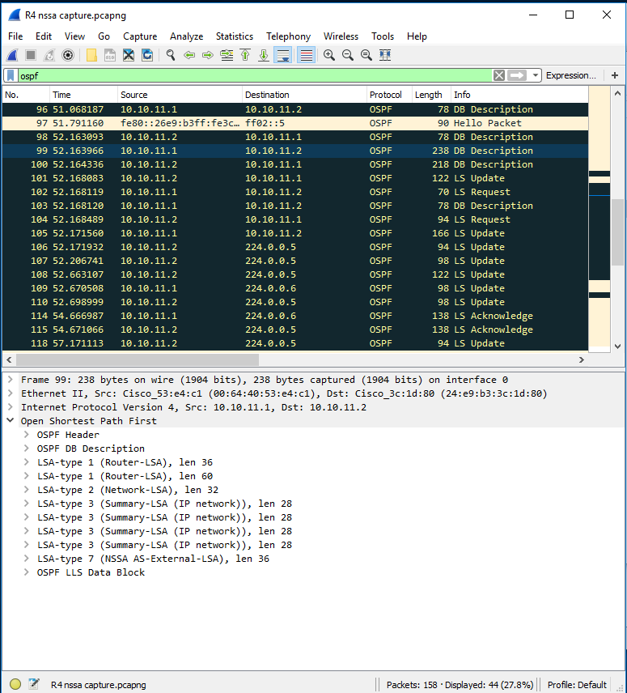

In an nssa area, directly connected external routes are transferred, but not processed. It’s like telling a person to pass your note without looking at the content. So, in this way, external routes passed to area 0 the backbone in form of type 7 LSA, occupying much less routers resources in nssa area.

## problems encountered

1. **OSPF and EIGRP network can’t connect to each other.**

*Solution: OSPF network and EIGRP network need to properly be distributed into each other on ASBR. In practice, I go to OSPF in SwitchR4 and redistribute EIGRP, then go to EIGRP on SwitchR4 and redistribute OSPF. Note that EIGRP has five constants to calculate distances, so the redistribution statements are very different.*

I used these command:

**SwitchR4(config)#**

router eigrp 1

redistribute ospf 1 metric 1544 200 255 1 1500

router ospf 1

redistribute eigrp 1 metric 100 subnets

1. **WireShark on PC is not getting any OSPF messages besides hello packets.**

*Solution: at first, I thought I could get packets by plugging the PC into the router ports, but apparently, I need a switch to do monitor sessions, replicate the traffic to other routers, and forward it to my PC. So, I configured* **layer3switchOSPFarea#** *to accomplish this task.*

Commands for monitor sessions:

**layer3switchOSPFarea1 (config)#**

monitor session 1 source interface Fa1/0/1

monitor session 1 destination interface Fa1/0/24

1. **There were not enough ports on Router 4 for WireShark capture.**

*R4, the ASBR between EIGRP network and OSPF network, needs to have three ports for this lab: one connected to OSPF area, one connected to EIGRP area, and another one for WireShark Capture. However, our routers only have two viable ports.*

***Solution****: we turned a layer 3 switch into R4, making SwitchR4. In this way, routing works the same, and we have enough ports for the lab.*

1. **We found LSA type 3 in totally stubby OSPF.**

*Routers in totally stubby OSPF area should filter out type 3 LSAs, inter-OSPF area LSAs. After checking our configuration, we still captured a type 3 LSA in our packets.*

***Solution****: Though this is not a “solution”, but it looks like the type 3 LSA packet we captured is a default summary route.*

## conclusion

OSPF stub area are designed to minimize the router resources that are spent to maintain an OSPF routing table. Different stub flavors provide different levels of concision, without impacting the connectivity of the network.

Although I don’t need to configure OSPFv3 in this lab, it was not easy. The first obstacle that I need to overcome is the connection between different routing protocols. Each routing protocol use distinct algorithm to calculate route distance, so the redistribution commands are different for different routing protocols. After the connection is established, turning an OSPF area into stub area relatively straight forward. Just make sure all routers in the area are in the same stub mode. The command is:

**“R1(config-router)#** area 1(or whatever area) stub (or nssa) no-summary (depending on whether you want it to be ‘totally’) **”**

Capturing the packets is another challenging aspect of the lab. Switch can do monitor sessions and forward OSPF packets to PCs. And a layer 3 Switch can act both as a router and a switch.